The Developer Diary

Side Scroller Platform Game

Mobile Application Development

Designer: Uamhan Lynch
Developer: Sarah Carroll-G00330821

Table Of Contents
Introduction…………………………………………………….…………3
Diary Entry………………………………………………………………….4
Test Plan……………..……………………………………..………………4
Developer Discussion…………………………………………….…..4
Game Process………….…………………………………………………6
Problems……………………………………………………………………9

Introduction
The mobile application I was given is designed by Uamhan MacFurgasan. It is a procedurally generated side scrolling platform. In this document I will discuss how I built this application and the altered design decisions , communication with Uamhan , and problems encountered along the way.
Diary
29.09.18
Received the project from Uamhan. Read though the design document and wrote down main points that need to be completed. The main list of tasks I came up with incuded.
- Create Unity application in 2D using Windows application.
- Create a player.
- Create prefabs for platforms.
- How to procedurally generating the platforms.
- Create separate scene for Menus.
- Create Scene for end game.
- How to mute.
- How to alter sound.
- How to kill a character and have end screen appear.
- How to calculate character score.
- How the character will move.
04.10.18
Created empty unity 2D application. Began research into each of the above questions. I investigated getting the camera to move as the player moves off the screen. In this case the objects are static and not being procedurally generated. I decided that when I begin design of the game there will be an initial platform. The player will start in space and when the player falls dynamically(ridgidBody2d) it will land on the platform below.

08.10.18
Begin Creating the game, Create player which initially is a red circle. The player have a script called PlayerMovement.cs. This controls the players movement and allows the player to move only to the right . This is done when the user pressed the right arrow key on the keyboard. The camera moves to the right as the player moves to the right. Therefore the player will always be in the centre of the screen besides the end of the camera. This is controlled by the CameraSystem.cs which is added to the main camera of the scene. The CameraSystem script is linked with the main camera of the scene.
Player dies when they fall off the screen -10 on y-axis. This is done in the PlayerHealth IEnumerator function. This is called as StartCoroutine("Die") when the player has died.

13.10.18
Added timer. This is the scoring mechanism of this game. The score is based on time passed since game began in seconds. The player falls and lands on a static platform. When the player falls from the platform they die. The player once died respawns in their original position and time restarts.
14.10.18
Added obstacle collider. Created procedural generated method to create an array of platforms. I do this from within the ObsicalController class. The CreateRandomObstical() is called. This takes an array of any length, and randomly generated them +5/-5 on y axis at a given x axis location.

15.10.18
Added Main menu scene, settings scene. Set up panal, canvas,buttons. Each button brings the user to a different location depending on the loadSceneOnClick class. This calls a function called LoadByIndex() and that called a scene number as specified in the build settings.

03.11.18
Added Pause and Score headers.

05.11.18
Added Score mechanism based on the length of time in seconds the player is alive for thoughout the game. This score is recorded in the score header and displayed when the player dies. This is a score canvas which is invisible until the user dies. It holds the users latest score along with the highest score achived in the game to date. Pause game added. This is done by setting “Time.timeScale = 1.0f;”. I added music to the game, however it players over the existing music when player changed scene.

06.11.18
Added the options menu and created mute functionality. The game is muted when the mute tick is on. The game can also be muted by reducing the sound bar to the far left. This is all controlled in the AudioController class.

09.11.18
Fixed music playing over each time the user begins, Still playing over each time the user goes back to the main menu(scene index 0). Deleted the game controller. Made the current existing files more relevant to namespace.

29.11.18
Attempted to link game with facebook. However I came across difficulties with this because as my mobile application is for universal windows platform. There is no possible way to link with the facebook sdk since new data restictions, unless the application is live on the windows store. I have left in the code I attempted commented out.

03.11.18
Added 2 new platforms. Made the player olaf. He is spinning, I know how to make him stop spinning “rb.freezeRotation = true;” However I have commented this out of the PlayerMovement because I like how he moves around in circles. I have created the change music scene. This scene allows the user change the current background music. However I am unable to stop the music that started playing initially in the spashScreen.

04.11.18
Increasing frequency of platforms after 20 seconds and after 70 seconds and after 80 seconds , This signifies the level difference in the game. I also got the music over writing the music started in the spashScreen scene. This is done by using a tag on the audio manager and passing that tag into the changeMusic function. I added an enemy(sven) to the game. The enemy disappears when touched by the player and decreases the players score by 5 points each time the player touches an enemy.

Test Plan
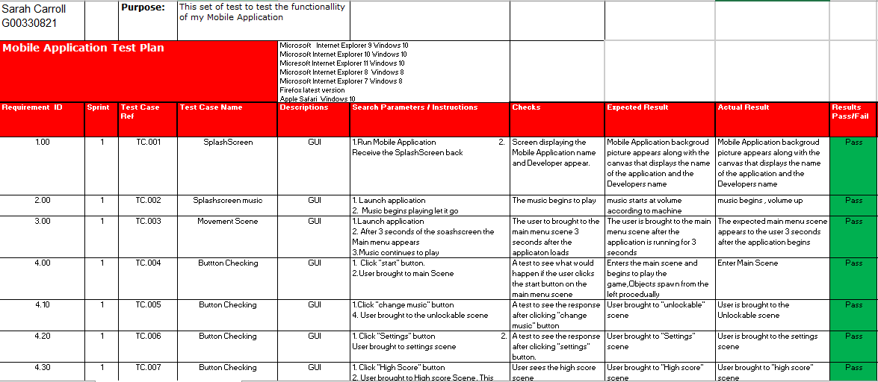
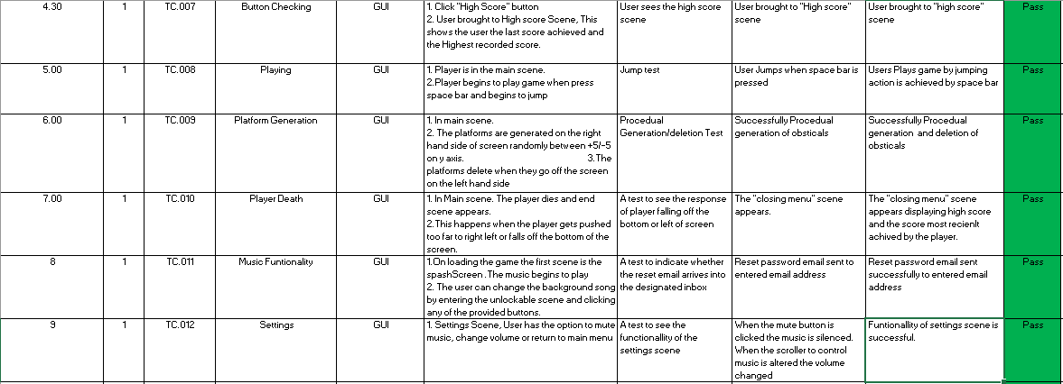
Developer Discussion
Though tout the Development of this project I was in communication with the designer on multiple occasions via email. I asked many questions that were not 100% clear to me in design document such as the sprites , background images, music and animation that was to be used in the game or how the enemies were to spawn. Uamhan replied to all my emails making the communication process very seamless. He left a lot of the appearance decisions up to me . He did say he wanted the enemies to decrease the score when they collide with the player.

Problems
- The biggest challenge I had when creating this game was figuring out how to procedurally generate the platforms and the enemies. I manger to do this by instantiating a game object for each enemy at a random interval of +5/-5 on the y axis and releasing each enemy at the given frequency.
- The changing music was also a difficulty component of the game, This was due to music playing on top of others. To resolve this problem I added a tag to the audio manager to ensure I was destroying the correct instance of audio manager.
- Creating the levels of this game was difficult because its an endless game. I decided to have the frequency of platforms change to increase difficulty after 20 seconds and again after 70 seconds. This makes it more difficult to avoid the enemies.

